

**Operating System**

**Lab # 08**

**Name: Zainab Bibi**

**Sap Id: 46462**

**Batch: BSCS 5thsemester**

**Submitted to: Mam Kausar**

**Lab Task**

**Note:** Include screenshots, required to illustrate your explanation for all Questions.

Q1: Write a C/C++ program that uses the fork() function and the logical AND (&&) operator.

This C++ code uses fork(), a system call that creates a new process.

• The code contains two fork() calls inside the condition of an if statement: if(fork() && fork()).

• This means the program will create two child processes (one for each fork()).

• The first fork() creates a child process.

• The second fork() creates another child process.

• The condition fork() && fork() checks if either fork() succeeds. If both creates a child, it runs the block inside the if statement, which has another fork().

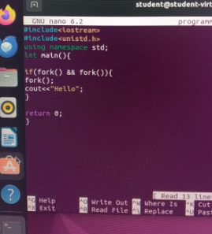

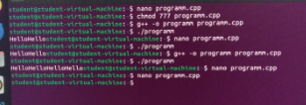

Q2: Write a C/C++ program that uses the fork() function and the logical OR (II) operator.

* The code contains two fork() calls inside the condition of an if statement: if(fork() || fork()).
* This means the program will create two child processes (one for each fork()).
* The first fork() creates a child process.
* The second fork() creates another child process. The condition fork() || fork() checks if either fork() succeeds. If either creates a child, it runs the block inside the if statement, which has another fork().

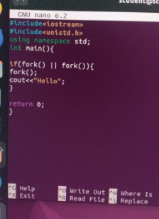



Q3: Write a C++ program that uses fork() to create a child process. Use an if-else statement.

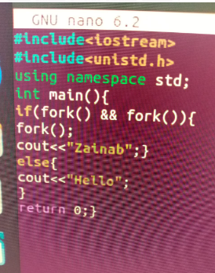

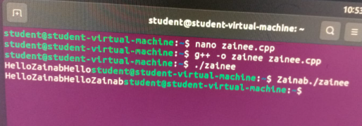

This C++ code now prints either "Zainab" or "Hello" depending on the outcome of the fork() calls.

* Each time fork() is called, a new child process is created, duplicating the current process.
* The fork() system call returns 0 in the child process and a positive integer in the parent process.
* The if condition is true only if both fork() calls return non-zero.
* A third fork() is called, which creates another child process.
* If the condition is false (at least one fork() call returns 0).The else block executes.